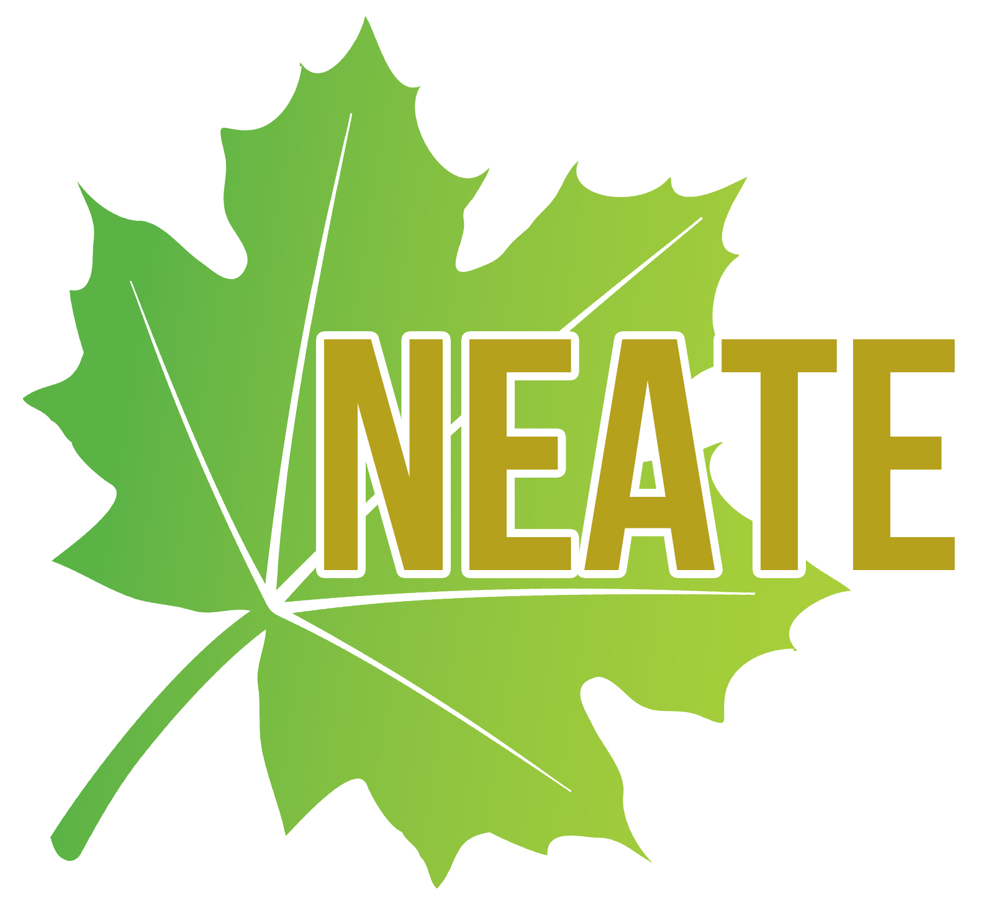
Annual NEATE Writing Contest for Students
Submission and Consent Form

Name: ____________________________________________________________________________________________
Address: __________________________________________________________________________________________
__________________________________________________________________________________________
Email: _____________________________________________________________________________________________
Age: ________________________________________________________________________________________________
Grade level: ________________________________________________________________________________________
Parent/Guardian Full Name: _____________________________________________________________________
Parent/Guardian Email Address: ________________________________________________________________
School: _____________________________________________________________________________________________
School address: ___________________________________________________________________________________
____________________________________________________________________________________
School phone #: ___________________________________________________________________________________
Name of sponsoring teacher: _______________________________________________________________________
Teacher Email: _______________________________________________________________________________________
(This teacher will certify that you are indeed a student in this school and will attest to your work being an original piece. This teacher does not have to be a member of NEATE. Teachers who sponsor the winning writers will receive a discount to attend the NEATE Annual Conference.)

Has this piece been submitted anywhere else? If yes, where and when? _______________________
_________________________________________________________________________________________________________
Your local paper: __________________________________________________________________________
NEATE, the sponsor of this writing contest, will publish the name and writing of each winner in their publications and promotional material. Before publishing your writing, NEATE requires your consent and the consent of a parent or guardian. By submitting this form you and your parent/guardian are agreeing to the following:
- You give permission to publish your name and writing in NEATE publications and promotions.
- You attest that the piece of writing is original and created by you.
- You understand that plagiarism disqualifies you from this contest.
Send completed submission form and work to: NEATEContest@Gmail.com
Please go to neate.org for Deadline information.

